LAB 4 Network Data Analysis using tcpdump

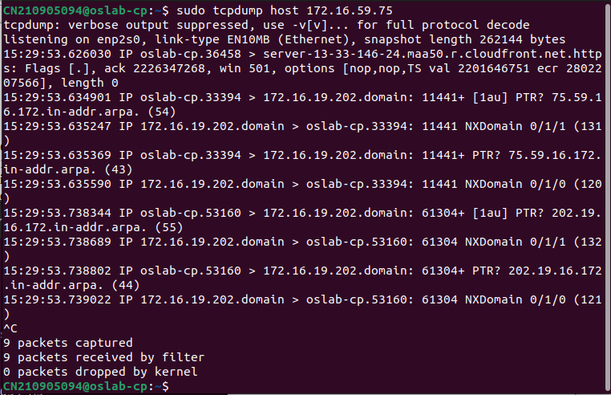
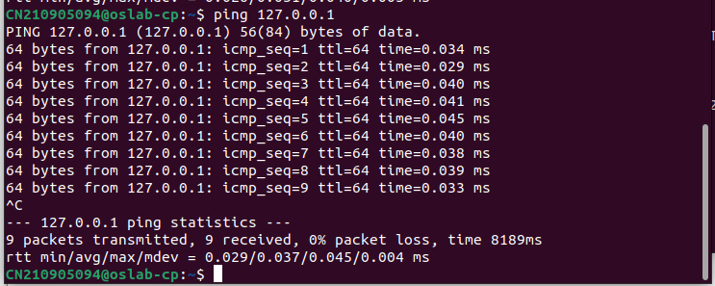
Q1) While tcpdump host your_host is running in one command window, run ping 127.0.0.1 from another command window. From the ping output, is the 127.0.0.1 interface on? Can you see any ICMP message sent from your host in the tcpdump output? Why?

Ans) Yes i Can see ICMP message sent from your host in the tcpdump output.ICMP (Internet Control Message Protocol) is a network layer protocol used by network devices, such as routers, to diagnose network communication issues.
Ping is a troubleshooting tool that uses ICMP to probe a remote host for a response.

Q2) While tcpdump host your_host is running to capture traffic from your machine, execute telnet 128.238.66.200. Note there is no host with this IP address in the current configuration of the lab network. Save the tcpdump output of the first few packets for the lab report. After getting the necessary output, terminate the telnet session. From the saved tcpdump output, describe how the ARP timeout and retransmission were performed. How many attempts were made to resolve a non-existing IP address? A) There are total 2 attempts made to resolve a non-existing IP address. ARP (Address Resolution Protocol) is used to map an IP address to a MAC address within a local network. When a host wants to communicate with another host on the same local network, it uses ARP to find the MAC address corresponding to the destination IP address. ARP TIMEOUT-:The host waits for a certain amount of time for an ARP response. This waiting period is known as the ARP timeout. If no response is received within this time, the host assumes that the target IP is not reachable. ARP Retransmission-:After the ARP timeout occurs without receiving a response, the host may decide to retransmit the ARP request. This retransmission is an attempt to ensure that the ARP request wasn't lost due to network congestion or temporary issues. The exact details of ARP timeout, retransmission intervals, and the number of attempts can depend on the operating system's networking stack and configuration. However, the general behavior described above applies to how ARP timeout and retransmission work in the context of the scenario you've outlined. 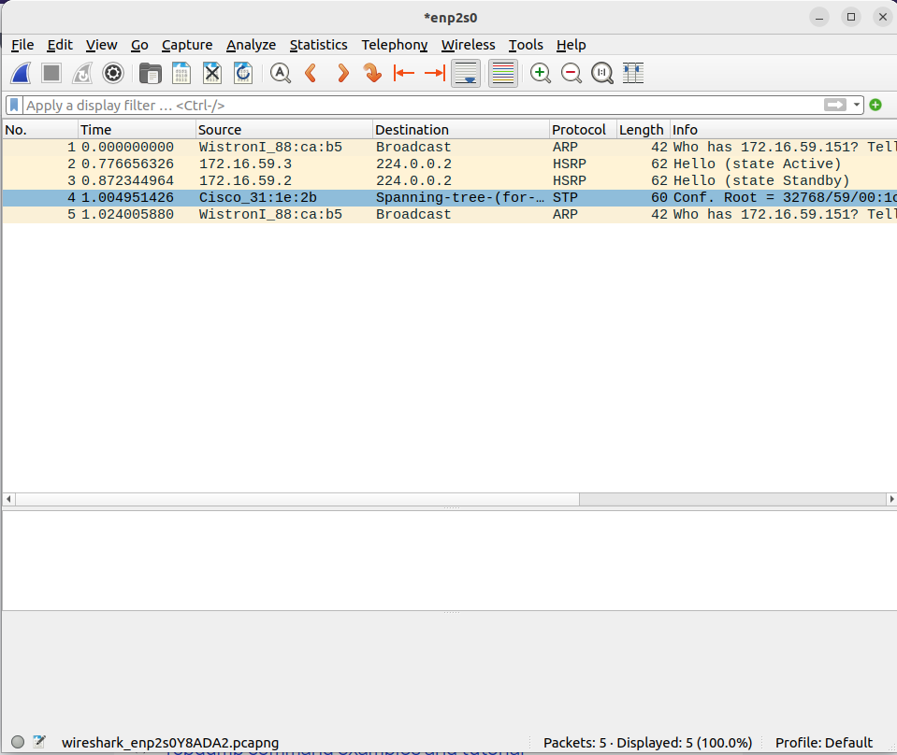 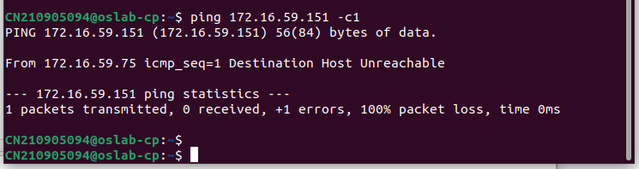 Q3)Briefly explain the purposes of the following tcpdump expressions. a. tcpdump udp port 520 b. tcpdump -x -s 120 ip proto 89 c. tcpdump -x -s 70 host ip addr1 and (ip addr2 or ip addr3) d. tcpdump -x -s 70 host ip addr1 and not ip addr2 Ans.a)This tcpdump expression captures UDP traffic that is sent to or received from port 520. Port 520 is associated with the Routing Information Protocol (RIP), a routing protocol used in networking. This command will display network packets that involve UDP communication over port 520. Ans.b)This expression captures IP packets with protocol number 89. Protocol number 89 corresponds to the OSPF (Open Shortest Path First) routing protocol. The -x flag will display the packet contents in both hexadecimal and ASCII format. The -s 120 flag limits the capture to 120 bytes of packet data. This command is useful to analyze OSPF packets and their contents. Ans.c)This expression captures network traffic involving ip addr1 and either ip addr2 or ip addr3. The -x flag displays packet contents in hexadecimal and ASCII format, and the -s 70 flag limits the capture to 70 bytes of packet data. This command helps analyze communication between ip addr1 and either ip addr2 or ip addr3. Ans.d)This expression captures network traffic between ip addr1 and any other IP address except for ip addr2. The -x flag displays packet contents in hexadecimal and ASCII format, and the -s 70flag limits the capture to 70 bytes of packet data. This command is useful when you want to capture communication involving ip addr1while excluding communication with ip addr2.

